Lab 3 – 10 points
Problem 1
You will again use the wUnderground web service but this time return from forecast

The day (title)
The forecast description (fcttext)

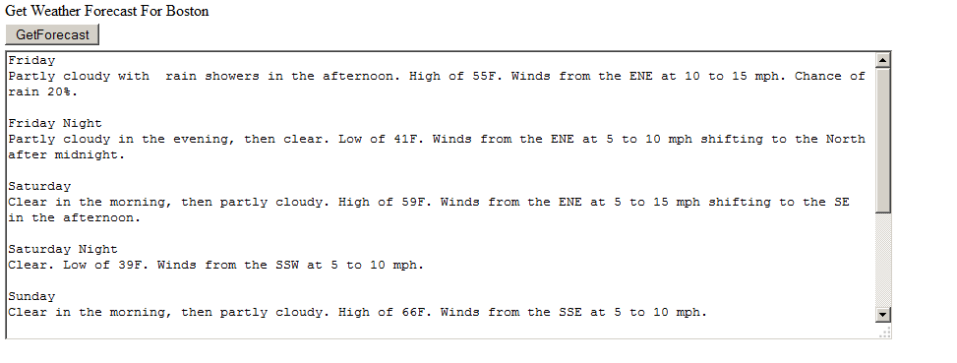
Problem 2

For this task, you will use the website www.geonames.org. For this program, you will need to make web service calls to accomplish the following tasks:

- List all cities for a given zip code
- List all nearby cities for a given zip code

These are two different buttons in your application, do not combine the two operations.

Note, you will not be able to discover this webservice, you must make a direct call to it via HTTP;

Here is one way to do it:
//Create Request
myHttpWebRequest = (HttpWebRequest)HttpWebRequest.Create(postalURL);
myHttpWebRequest.Method = "GET";
myHttpWebRequest.ContentType = "text/xml; encoding='utf-8'";
//Get Response
myHttpWebResponse = (HttpWebResponse)myHttpWebRequest.GetResponse();

//Load response stream into XMLReader
myXMLReader = new XmlTextReader(myHttpWebResponse.GetResponseStream());

In both cases you will output the zip code and city. The user will enter a zip code. I will be entering (it only takes 5 digit zip codes):
02864
0286

